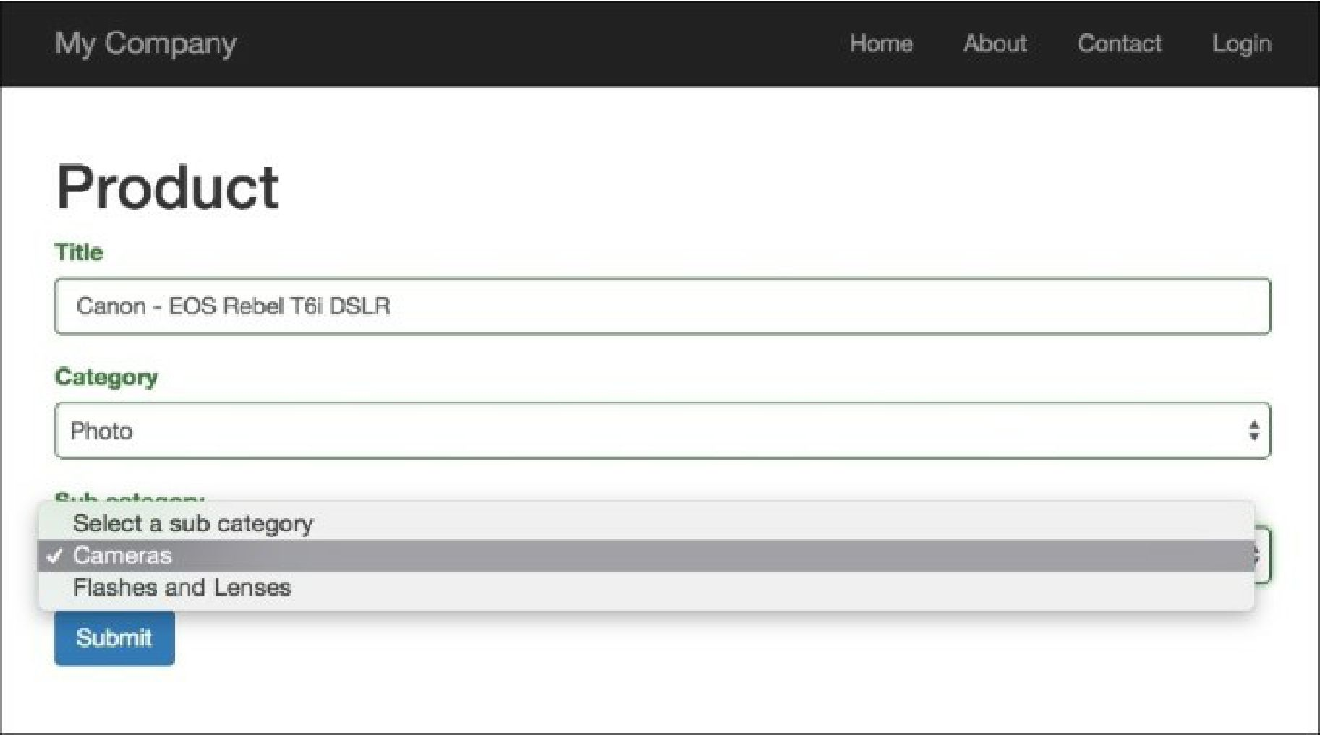

1. That is it. If you select another category, you will get sub-categories of this category.

How it works...

In this example, we have two dependent lists with categories and sub-categories, and one model, Category. The main idea is simple: we just bound the JQuery onChange event to the category_id field in our form. Every time a user changes this field, our app sends an AJAX request to the get -subcategories action. This action returns a JSON-formatted list of sub-categories, and then, on the client- side, we build a list of options for our sub-categories list.